**Hritik Ajay Bansal  
CSE A 15**

**180905105**

**IT LAB WEEK 5**

**Q1)**

**Settings.py**

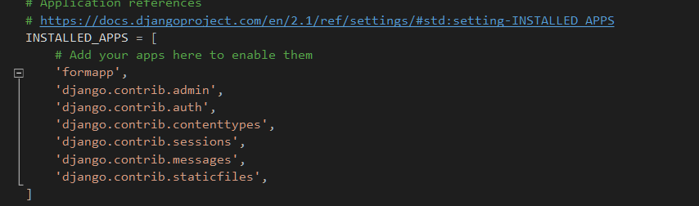

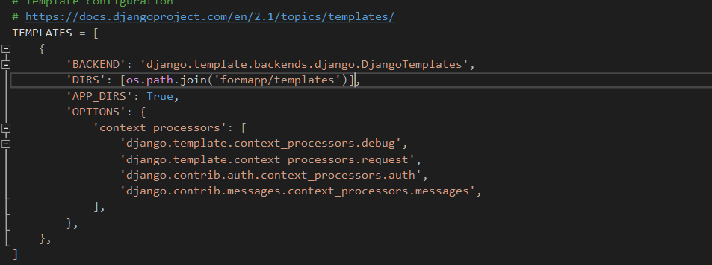

**Formapp/urls.py**

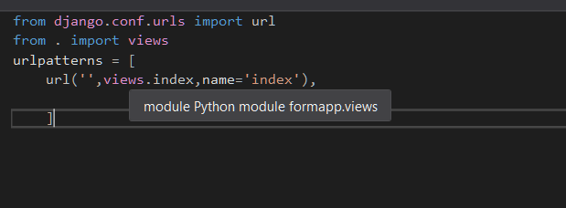

**Formapp/views.py**

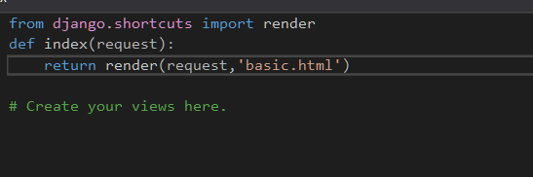

**Question1\urls.py**

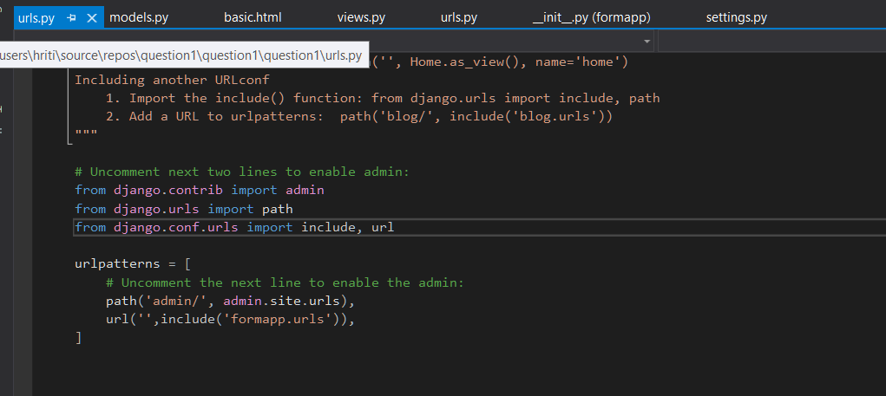

**Formapp\template\basic.html**

<!doctype html>

<html>

<head>

<meta charset="utf-8">

<title>Student Marks</title>

</head>

<body>

<script type="text/javascript">function myfunc(){

var name = document.getElementById("name").value;

var dob = document.getElementById("dob").value;

var add = document.getElementById("address").value;

var ph = document.getElementById("phone").value;

var email = document.getElementById("email").value;

var phy = document.getElementById("phy").value;

var chem = document.getElementById("chem").value;

var eng = document.getElementById("eng").value;

var val = parseFloat(phy) + parseFloat(chem) + parseFloat(eng);

console.log(val);

val = val/3;

console.log(val);

var s = "Name : "+name + "\nDOB : "+dob+ "\nAddress : "+add+"\nContact Number : "+ph+"\nEmail : "+email;

document.getElementById("txt").value = s;

document.getElementById("para1").innerHTML = "Percentage is "+val;

}</script>

Enter Name: <input type="text" id="name"><br>

Enter DOB: <input type="text" id="dob"><br>

Enter Address : <input type="text" id="address"><br>

Enter Number: <input type="text" id="phone"><br>

Enter Email: <input type="text" id="email"><br>

Enter Phy marks: <input type="text" id="phy"><br>

Enter Chem marks: <input type="text" id="chem"><br>

Enter Eng marks: <input type="text" id="eng"><br>

<button onclick="myfunc()">View</button><br\>

<br /><br />

Details : <textarea id="txt" rows="10" cols="20"></textarea>

<p id="para1"></p>

</body>

</html> **OUTPUT:**

